

Document Version History

|  |  |  |  |  |
| --- | --- | --- | --- | --- |
| Version | Owner | Source | Date | Description |
| 1.0 | Chris Baugh |  | 04-Nov-2013 | Initial Draft |
|  |  |  |  |  |
|  |  |  |  |  |
|  |  |  |  |  |
|  |  |  |  |  |
|  |  |  |  |  |
| For review: | | | | For approval: |
|  | | | |  |
|  | | | |  |
|  | | | |  |
|  | | | |  |
|  | | | |  |

Table of Contents

1. About this Document 3

1.1 Authors 3

1.2 Document Summary 3

1.3 Reference documents 3

1.4 Distribution 3

2. Introduction 4

3. New Functionality 5

3.1 4 Character XSPs (Enhancement) 5

3.2 Cyclic Maintenance (Enhancement) 5

3.3 Item Code Breakdowns form (mai1940) 5

3.4 Allow Multiple Final Invoice files to be processed through CIM Interface 5

3.5 Priorities by Admin Unit 6

3.5.1 MAI3812 - Defect Priorities 6

3.5.2 MAI1325 - Enquiry/Defect Priorities 8

3.5.3 MAI3813 – Maintain Automatic Defect Prioritisation 9

3.5.4 MAI3807 – Locator Create Defects 9

3.5.5 MAI3808 – Inspections 9

3.5.6 MAI3818 – Work Order Automation Rules 10

3.5.7 Inspection Loader 10

3.6 New Product Options 10

3.6.1 UPDWOTGT 10

3.6.2 CIMMULTIF 11

3.6.3 PEDDATEATR 12

4. Security Policies 13

4.1 Applying Security Policies 13

5. Fixes, Enhancements and Changes at 4.7.0.0 15

# About this Document

## Authors

* Chris Baugh

## Document Summary

This document provides a description of the changes in this release and information about how these changes may impact on an installation.

## Reference documents

None

## Distribution

Bentley/Exor Customers, Partners and Colleagues

# Introduction

This document defines the changes made to the Maintenance Manager product at release plus a list of all logs fixed in this release.

Unlike the “Maintenance Manager Installation/Upgrade Guide”, this document is specifically targeted at the Maintenance Manager end user. Therefore, if the recipient of this document is an IT person please ensure that it is forwarded on to the relevant end user(s).

This document does not comprehensively describe the functionality of the product, or act as a User Guide.

This release is available as an upgrade from release 4.5.0.0., 4.5.2.0, 4.6.0.0 and 4.6.1.0 of the Maintenance Manager product.

Please note that any data shown in example screenshots does not represent any Customer’s live data; it is test data set up by Exor.

After reading through this document, should you have any further Maintenance Manager training or Consultancy requirements then please contact your Exor account manager.

# New Functionality

## 4 Character XSPs (Enhancement)

Maintenance Manager has been updated to support 4 character XSPs.

## Cyclic Maintenance (Enhancement)

A number of changes have been made for cyclic maintenance when the "Schedule By Asset" flag is set to 'Y' in Cyclic Maintenance Schedules form (MAI3860):

* Correct the calculation of quantities.
* Calculated Quantity is now automatically copied to the Actual Quantity
* Changed the Cyclic Works Order form (MAI3800A) to generate a Works Order Line for each Asset regardless of the USECYCGRP product option.
* Corrected the display of Asset information on Works Order Lines in the Cyclic Works Order form (MAI3800A).
* Schedules with the "By Asset" flag set to 'Y' can no longer be queried in the Cyclic Maintenance By Road Section Form (MAI3862).

## Item Code Breakdowns form (mai1940)

This form has been modified to allow all users, who have been granted access, to define details for any Agency to which they have access. Product option ICBFGAC will influence the details that can be defined as follows:

|  |  |
| --- | --- |
| ICBFGAC = ‘N’ | Setting the option to ‘N’ will ensure details are unique at system level. This will prevent the duplication of Item Code Breakdown details across all Agencies.  Note: It is advised that only top level Admin Unit users should be granted access to the form if the product option is set to ‘N’ |
| ICBFGAC = ‘Y’ | Setting the option to ‘Y’ will ensure details are unique at agency level. This will allow for Item Code Breakdown details to be defined for each Agency.  Note: An Agency code must be linked to the Admin Units that are to define their individual Item Code Breakdowns using Admin Units form (hig1860). |

## Allow Multiple Final Invoice files to be processed through CIM Interface

CIM has been enhanced to allow for the processing of multiple Final Invoice files, depending on product option CIMMULTIF.

CIMMULTIF = ‘Y’: Final Invoices will be processed, even though a Final Invoice file has subsequently been processed.

CIMMULTIF = ‘N’: Processing will be performed as it is currently i.e. only a single Final Invoice is permitted

The following rules apply, for multiple Final invoice processing:

If CIMMULTIF = ‘Y’, the Final invoices will be treated similar to the Interims.  So a Final sequence number will need to be specified in the Record Type 5 (currently null for Final invoices) so that the Finals are processed in the correct order

For each Final invoice received the Work Order line completion date will be updated according to the Date Completed on the 10 record

The Completion Date on a Work Order will be the latest completion date received on a Final Invoice for a Work Order Line

## Priorities by Admin Unit

Maintenance Manager has been modified to allow Defect Priorities to be defined by Admin Unit, providing the flexibility to define a separate set of rules for each Admin Unit, if required.

As a default, upgrade scripts have been provided to ensure existing rules will be defined at the top level Admin Unit, allowing for business as usual.

Addition of the Admin Unit to Defect Priorities will provide the ability for an Admin Unit to define a Target Response Time of their choosing to a Maintenance Activity, Defect Priority, Repair Type combination, overriding the details set at a higher level in the Admin Unit hierarchy.

### MAI3812 - Defect Priorities

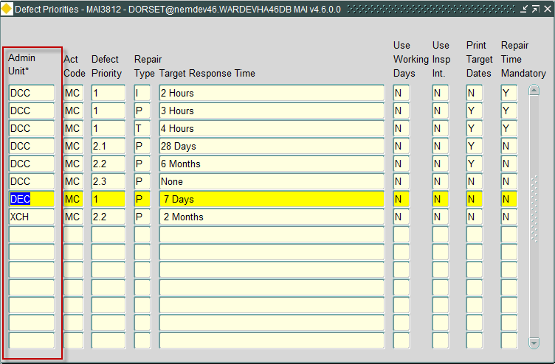

The Defect Priorities form has been modified to include Admin Unit allowing for Target Response times to be defined by Admin Unit. The following rules apply, for any user accessing this form

* Only rules to which the User has been granted Admin Unit privileges will be accessible by the User.
* Any rules defined for an Admin Unit will override those defined at a higher level in the Admin Unit hierarchy.

Using the details shown in the Defects Priority form shown above, as an example. if the Admin Unit hierarchy is as follows:

DCC

DEC

XCH

For Admin Unit DCC, the following set of Priorities will apply for Activity Code ‘MC’:

|  |  |  |
| --- | --- | --- |
| Defect Priority | Repair Type | Target Response Time |
| 1 | I | 2 Hours |
| 1 | P | 3 Hours |
| 1 | T | 4 Hours |
| 2.1 | P | 28 Days |
| 2.2 | P | 6 Months |
| 2.3 | P | None |

For Admin Unit DEC, the following set of Priorities will apply for Activity Code ‘MC’:

|  |  |  |
| --- | --- | --- |
| Defect Priority | Repair Type | Target Response Time |
| 1 | I | 2 Hours |
| 1 | P | 7 Days |
| 1 | T | 4 Hours |
| 2.1 | P | 28 Days |
| 2.2 | P | 6 Months |
| 2.3 | P | None |

For Admin Unit XCH, the following set of Priorities will apply for Activity Code ‘MC’:

|  |  |  |
| --- | --- | --- |
| Defect Priority | Repair Type | Target Response Time |
| 1 | I | 2 Hours |
| 1 | P | 7 Days |
| 1 | T | 4 Hours |
| 2.1 | P | 28 Days |
| 2.2 | P | 2 Months |
| 2.3 | P | None |

Note: Where values defined for an Admin Unit override those at a higher level, these have been highlighted

### MAI1325 - Enquiry/Defect Priorities

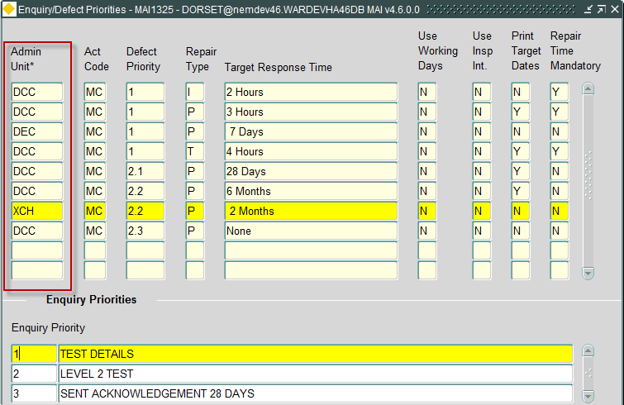

The Enquiry/Defect Priorities form has been modified to include the Admin Unit associated with the Defect Priority. The following rules apply, for any user accessing this form

* Only Rules to which the User has been granted Admin Unit privileges will be accessible by the User.

Specification of Enquiry Priority, for the selected Defect Priority, will take account of the selected Defect Priorities Admin Unit ensuring that Enquiry Priorities are correct for the currently selected Admin Unit.

### MAI3813 – Maintain Automatic Defect Prioritisation

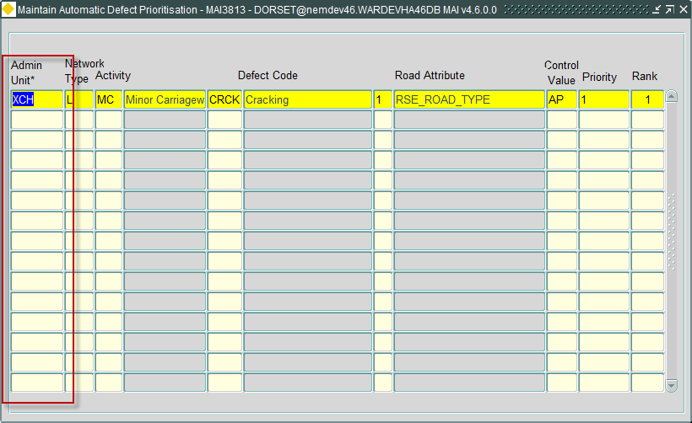

The Maintain Automatic Defect Prioritisation form (MAI3813) has been modified to allow for Automatic Defect Priorities to be defined by Admin Unit. The following rules apply, for any user accessing this form

* Only Rules to which the User has been granted Admin Unit privileges will be accessible by the User.

### MAI3807 – Locator Create Defects

Locator Create Defects form (MAI3807) has been modified to accommodate the addition of the Admin Unit to Defect Priorities as follows:

* Valid priorities will be based on the list of Defect Priorities defined in the Defect Priorities form (MAI3812) for the Activity, and where the Admin Unit is within the Admin Unit hierarchy of the associated network
* Allowed repair types, defined in the Defect Priorities form (MAI3812), for a defect, are based on the Activity and the Admin Unit of the associated Network.
* The calculation of the Repair due date will take the Admin Unit of the associated Network into account, when identifying the appropriate Defect Priorities values to be used in the calculation
* If Automatic Defect Prioritisation is being used (defined by product option DEFAUTOPRI), the Admin Unit of the Network assigned to the Defect, along with the Defect Activity, will be used to identify appropriate details, defined in Maintain Automatic Defect Prioritisation form (MAI3813)

### MAI3808 – Inspections

Inspections form (MAI3808) has been modified to accommodate the addition of the Admin Unit to Defect Priorities as follows:

* Determination of whether Repair Time specification is mandatory, will be based on the associated Defects Priority entry, defined in the Defect Priorities form (MAI3812) for the Activity, and where the Admin Unit is within the Admin Unit hierarchy of the associated network
* Allowed repair types, defined in the Defect Priorities form (MAI3812), for a defect, are based on the Activity and the Admin Unit of the associated Network.
* The calculation of the Repair due date will take the Admin Unit of the associated Network into account, when identifying the appropriate Defect Priorities values to be used in the calculation
* If Automatic Defect Prioritisation is being used (defined by product option DEFAUTOPRI), the Admin Unit of the Network assigned to the Defect, along with the Defect Activity, will be used to identify appropriate details, defined in Maintain Automatic Defect Prioritisation form (MAI3813)

### MAI3818 – Work Order Automation Rules

Work Order Automation Rules form (MAI3818) has been modified to accommodate the addition of the Admin Unit to Defect Priorities as follows:

* Allowed repair types, defined in the Defect Priorities form (MAI3812), for a defect, are based on the Activity and the Admin Unit of the associated Network.

### Inspection Loader

The Inspection loader has been modified to accommodate the addition of the Admin Unit to Defect Priorities as follows:

* Allowed repair types, defined in the Defect Priorities form (MAI3812), for a defect, are based on the Defect Activity and the Admin Unit of the associated Network.
* Validation of the Defect Priority will ensure that the value is valid for the Defect Activity and the Admin Unit of the associated Network.
* The calculation of the Repair due date will take the Admin Unit of the associated Network into account, when identifying the appropriate Defect Priorities values to be used in the calculation
* The Admin Unit of the associated Network will be used in the identification of the rules defined in Work Order Automation Rules form (MAI3818) to determine if Work Orders should be automatically created for the details being processed

## New Product Options

### UPDWOTGT

When the product option UPDWOTGT is set to ‘Y’ the Work Order Target date in MAI3800 will not be automatically calculated, based on the Work Order Line target dates and Work Order Priority, but will allow for manual specification.

The Work Order Target date will only be populated if a Work Order Priority is entered. Otherwise, the value will be NULL requiring population before Authorisation or Instruction.

The product option will be initially set to ‘N’.

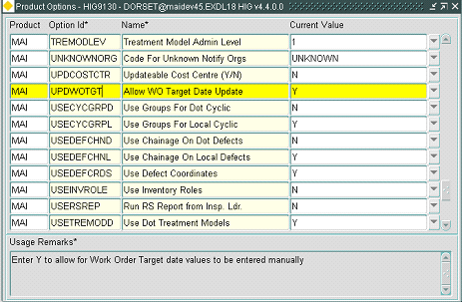

This product option has two values:-

N = Work Order Target date is automatically populated

Y = Work Order target date is not populated, and requires manual specification.

### CIMMULTIF

When set to ‘Y’, CIM Final Invoice files can be processed, even though a subsequent Final invoice file has been processed ie. The product option, when set to ‘Y’, will allow for multiple Final invoice files to be processed through CIM

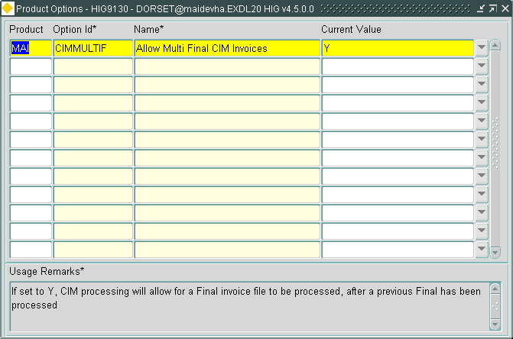

Note: When modifying the Product Option value, a refresh is required to ensure the Product Option change has been applied

### PEDDATEATR

New Y/N Product Option "PEDDATEATR" used to determine how asset type date attributes are exported in the PEDIF file.

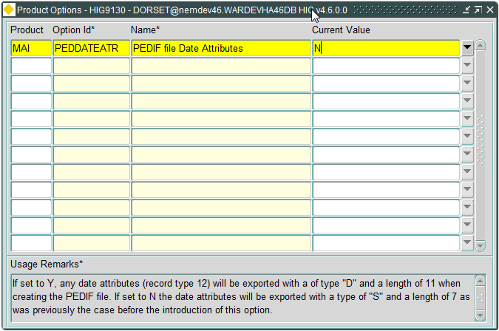

This product option has two values:-

N = Date Attributes are exported as a type “12” record with “S” as the datatype and a length of 7 as was previously the case. This is the Default value.

Y = Date Attributes are exported as a type “12” record with “D” as the datatype and a length of 11.

# Security Policies

The optional facility to enable fine-grained access control has been introduced in this release. This will provide row-level access to a number of tables governed by the default admin-unit of the user and admin units stored or derived from data in the table.

All users flagged as restricted will be prevented from selecting data from these tables if the row relates to a network element, an agency or admin unit outside of the users direct access down the hierarchy. The network tables and the admin-unit table are restricted so users can read data both above and below that of their direct access.

## Applying Security Policies

The addition of fine-grained access control can be enabled by applying the following packages, and policy scripts in the order given, as specified:

All exor applications that are installed are located in the same destination – what is often referred to as <exor_base>.

* Change directory to <exor_base>\mai\admin\ctx
* Login to SQL*PLUS as the SYS user on the client PC and run the following commands, in the order given:
* START maisec.pkh
* START maisec.pkw
* START hig_process_security.pkh
* START hig_process_security.pkw
* START drop_maiausec_policy.sql
* START add_maiausec_policy.sql
* START drop_process_policy.sql
* START add_process_policy.sql

This will provide row-level access to a number of tables governed by the default admin-unit of the user and admin units stored or derived from data in the table.

The affected tables are listed below:

|  |
| --- |
| ACTIVITIES_REPORT |
| DEFECTS |
| MAI_INSP_LOAD_ERROR_DEF |
| MAI_INSP_LOAD_ERROR_REP |
| BUDGETS |
| ITEM_CODE_BREAKDOWNS |
| MAI2325_RESULTS |
| MAI_AUTO_WO_RULES |
| MAI_INSP_LOAD_ERROR_ARE |
| LOCAL_FREQS |
| DEF_SUPERSEDING_RULES |
| ORG_UNITS |
| WORK_ORDER_LINES |
| DELETED_DEFECTS |
| REPAIRS |
| SCHEDULES |
| SCHEDULE_ROADS |
| HIG_PROCESSES |
| MAI_INSP_LOAD_BATCHES |

# Fixes, Enhancements and Changes at 4.7.0.0

The following are a list of internal task identifiers with associated ECDM fault logs/Bentley TSG Service requests that have led to changes in the 4.7.0.0 release. Please note the list covers the distinct set of fixes over and above the initial 4.5.0.0 release. Many of the items on the list have already been supplied as fixes to the 4.5.0.0, 4.5.2.0, 4.6.0.0 and 4.6.1.0 releases.

| Internal Reference | Issue | TSG Service Requests and/or support log numbers | |
| --- | --- | --- | --- |
| 0111048  0112228 | When executing a query in Payment Approval form (MAI3856), previously entered criteria was not being cleared under certain circumstances. The only way of resolving this was to exit the form, and re-enter the details. Also, % difference calculations being calculated incorrectly. These issues have now been resolved |  | |
| 0111775  0112223 | Maintain Works Order - Contractor Interface form (MAI3802) did not highlight any document associations on the toolbar. The form has been modified to indicate any associations | 8001274055 | |
| 0111543  0112227 | Attributes were missing from the Translation Views, causing an error in MAI1400 when pressing the 'Create View' button. The views have been modified to resolve this problem | 8001187233 | |
| 0111950 | A number of changes have been made for cyclic maintenance when the "By Asset" flag is set to 'Y':- - Correct the calculation of quantities. - Calculated Quantity is now automatically copied to the Actual Quantity - Changed the Cyclic Works Order form (MAI3800A) to generate a Works Order Line for each Asset regardless of the USECYCGRP product option. - Corrected the display of Asset information on Works Order Lines in the Cyclic Works Order form (MAI3800A). - Schedules with the "By Asset" flag set to 'Y' can no longer be queried in the Cyclic Maintenance By Road Section Form (MAI3862). | 8001341645 | |
| 0111986  0112220 | Corrected an issue copying the 51st and 52nd attributes to the error tables during phase 2 of an Inventory Load. |  | |
| 0111990  0112219 | Removed hard coding of the CVI and DVI Survey asset types when checking for overlaps during Stage 2 of an Inventory Load. |  | |
| 0112019  0112218 | When processing an Inspection file, via Inspection Load process, if Automated Work Order Rules definitions exist, containing the same criteria for earlier financial years, an error is produced, preventing creation of the Work Order. Modifications have been made to overcome this problem | 8001357014 | |
| 0112031 | In MAI3808 when selecting an asset to raise a defect, if the asset types do not match in MAI1400 (Inventory Control Data), an error occurs when calling locator. Also, when the asset details are populated in MAI3808, after the call to locator, the validation of XSP fails. MAI3808 has been modified to ensure the translation of asset types is correct, resolving this problem. |  | |
| 0112037  0112216 | Saving a change to a work order description can result in the estimated quantity on a BOQ item being overwritten.  When a WO contains a WOL in INTERIM status, as a result of processing a CIM WI file or manually set, the estimated quantity value is being overwritten on update of the WO description. MAI3800 has been modified to resolve this. | 8001350141 | |
| 0112039  0112214 | When copying an existing WO, by pressing the Copy button. The WO header actual costs appear to be copied from the original. MAI3800 has been modified to resolve this |  | |
| 0112018 | Under certain circumstances, when a user queries Work Order Details, scrolling through the returned list and pressing 'Exit' will result in a 'Do you want to save changes' message. Pressing 'Yes' can result in some of the Work Order costs being overwritten by values from previously queried Work Orders. | 8001373334  8001478555 | |
| 0112238  0112045 | In Raise Work Orders form (MAI3801), if a user leaves the Budget LOV active without choosing details, it can prevent other users from creating Work Orders. To overcome the chance of users locking each other out, details are now commited once a budget has been selected. The resulting Dialogue presented after choosing a budget now only includes an OK button, presenting the user with the Work Order created, once pressed. | 8001385606 | |
| 0112264 | In MAI3800, if the contract is changed on a Work Order, until the change is commited other users may experience locking when trying to create Works Orders for the same contract. MAI3800 has been modified to commit details after a contract change has been made |  | |
| D-119368 | When attempting to cancel a work order in Cancel Works Order form (mai3610) an error is produced when attempting to save, preventing the cancellation. The form has been modified to resolve the problem. | 8001532843 | |
| D-121060 | When Creating a Work Order via Defects form (MAI3806), if the Defect contains 2 repairs, a unique constraint error is encountered. The form has been modified to cope with multiple repairs on a defect. | 8001595382 | |
| D-120740 | When two or more users are trying to update the same flexible attribute on different WO references, error (record locked by another user) is returned. Maintain Flexible Attributes form (MAI3821) has been modified to resolve this. | 8001574396 | |
| D-122787 | When entering Work Order details, in Work Orders (Defects) form (MAI3800), it’s possible to instruct a Work order where the cost will exceed the budget limit. The form has been modified to resolve this. | 8001606406 | |
| D-122788 | When instructing a Work Order, if errors are encountered, there are occasions when the Work Order can become instructed, but remains at DRAFT status, see above. Work Orders (Defects) form (MAI3800) has been modified to resolve this. | 8001555024 | |
| D-123220 | A valid WC file is processed into the system without error but the process monitor indicates FAIL. Modifications have been made to indicate success for this scenario | 8001475643 | |
| D-125250 | Allow for the processing of Multiple Final Invoice files through the CIM interface |  | |
| D-126107 | A work order line completed through interfaces at a lower cost than the estimate does not wipe the remaining committed amount from the budget – giving a misrepresentation of monies spent in the budget |  | |
| D-124477 | In MAI3802 contractors are allowed to enter and save the BOQ quantity values that are outside the range indicated in MAI3888 form for the particular standard item despite error messages appearing before save.  Note: After the fix has been applied there may be BOQ quantities that exceed the maximum quantity specified in MAI3888, these will need to be corrected, if required | 7000014146 | |
| 0112015 | Maintenance Manager modules have been updated to work with 4 character XSPs. |  | |
| 0112310  0112309 | Fixed a bug that caused an "ORA-20000: HIG-0067: Record not found: nm_inv_types (ITY_PK) nit_inv_type => XX" error when loading an inspection file containing 2 character asset type codes and 4 character asset codes are being used in Asset Manager. |  | |
| 0111303 | When defining details in Composite Flexible Attributes form (MAI3819), the label will allow for 30 characters. When displaying the details in Maintain Flexible Attributes form (MAI3821), the label was being truncated. The form has been modified to allow for 30 character labels | 8001094336 |
| 0111890 | In Organisations form (MAI1870), Organisations type validation allowed for end-dated details. Validation has been modified to exclude end-dated details. |  |
| 0111959  0111958 | The network and asset type details were not populated correctly in Locator when the Find Asset function is used in the Inspections form (MAI3808) to associate an asset with a defect. |  |
| 0112028 | Cyclic Schedules are now displayed in Navigator as part of an asset hierarchy. |  |
| 0112215  0112038 | When a Work Order Line status is set to COMPLETED, and BOQ_ITEMS button has been pressed, BOQ quantities cannot be updated. MAI3800 has been modified to resolve this |  |
| 0112217 | In MAI3808 when selecting an asset to raise a defect, if the asset types do not match in MAI1400 (Inventory Control Data), an error occurs when calling locator. Also, when the asset details are populated in MAI3808, after the call to locator, the validation of XSP fails. MAI3808 has been modified to ensure the translation of asset types is correct, resolving this problem. |  |
| 0112222  0111777 | Work Order Summary Report (MAI3505) was not including details for end-dated sections. | 8001227408 |
| 0112224  0111750 | When selecting a defect on to a Work Order using Works Orders form (MAI3800) error message 'Unexpected error occurred ORA-00923: FROM keyword not found where expected.' was being produced. Changes have been made to resolve this | 8001251817 |
| 0112225  0111604 | When creating a Work Order via locator, or via the Inspections form, the Work Order target date was being populated if manual entry was required (by specification of UPDWOTGT = 'Y'). Also, if Work Orders were being automatically created via the Inspection Load, the date was also being populated if the product option was set and auto-instruction had not been specified in the Work Order Automation rules. Modifications have been made to overcome these problems. | 8001212150 |
| 0112298 | 1, When contract security (Product Option CONSECMODE) is set to User (“U”) the currently connected user will automatically be added to any new Contractor.  2, Change to the Contractors form (MAI3881) to restrict the users and roles that can be entered in the Contract Security tab. Only users with the same or lower admin unit as the logged in user and only roles that have been granted to the logged in user are allowed. |  | |
| D-116399 | Fixed an issue that was leading to duplicated type “5” records and duplicate attribute data on type “6” records when multiple PEDIF files are generated within a single session. |  | |
| D-115691 | New Y/N Product Option "PEDDATEATR" used to determine how asset type date attributes are exported in the PEDIF file.  If the product option is set to "Y" then any type "12" record for date attribute will contain "D" for the datatype and have a length of 11 otherwise the datatype will be "S" and the length will be 7 as has previously been the case.  The default value for the new product option is "N". | 8001501691 | |
| 0112323 | When creating a Works Order from Locator (NM0572) using `Raise Small Scheme Work Order’ the initial status of the Work Order is automatically set to INSTRUCTED. The form has been modified to ensure that all WO Line statuses, and the associated Work Order status are set to the initial status (Usually DRAFT status). |  | |
| TK-251374 | The type “12” records (Asset Type Attributes) in the PEDIF File are now ordered by Sys Flag, Asset Type and Display Sequence Number. |  | |
| TK-251375 | When the Product Option PED4CHRASS is not set to "Y" the type "15" records (XSPs) in the PEDIF File will contain the 2 character translated Asset Type. |  | |
| TK-251439 | Asset validation in the Maintenance Inspection Loader has been changed to ensure that the asset is “Live” and located on the inspected section on the date of the inspection and reject any defect that violates this rule.  The following changes have been made in the "Maintenance Inspection Summary/Error Correction" form (MAI4405):-  Allow a defect to be deleted if the associated asset is invalid.  Fixed a “value error” when using “Find Asset” in the defect details block.  Asset type is now correctly updated when “Find Asset” is used in the Defects Block.  The Network Filter is now correctly set to the inspected section in the “Find Asset” form.  Prevent records being created or deleted in a number of blocks.  Enable/Disable the Create/Delete record buttons in the toolbar as appropriate.  Prevent editing in the “Invalid Files” tab once the load process has progressed beyond this stage. |  | |
| D-119840 | After querying back details in Work Order Automation form (mai3818), error ‘ORA-04062 signature of package … ‘ is encountered when scrolling through the details. The form has been modified to overcome this. | 8001565001 | |
| D-119843 | Item Code Breakdowns form (mai1940) only allows ICBs to be added if the user is the top level System Admin user. The form has been modified to allow users to define details for any Agency to which they have access. | 8001551192 | |
| D-118546 | When loading an inspection file as a sub-ordinate user - where a distinct time interval has been defined for a defect priority at the sub user level then the load works OK, but when a defect has a priority that has to be derived from a higher level in the admin unit tree then the load fails |  | |
| D-127522 | Performance problems were being experienced when creating Work Orders from Locator which is encountered when populating the Budgets List of Values in mai3801. |  | |
| Bug #42060 | Budget selection is not being restricted by admin unit and when a single defect is selected for addition to a work order the resulting work order has two work order lines both with the same defect id | 7000055924 | |